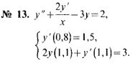

[0,8; 1,1]
//y’ (0,8) = 1,5 => y (0,8) = 1,5x = 1,5 x 0,8 = 1,2 = y₀ ,

y’’ = (y_{i + 1} – 2y_{i} + y_{i - 1})/h² , y’ = (y_{i + 1} – y_{i - 1})/2h ,

(y_{i + 1} – 2y_{i} + y_{i - 1})/h² + 2 (y_{i + 1} – y_{i - 1})/2hx_{i} – 3y_{i} = 2 ,
y' (0,8) = (-y₂ + 4y₁ – 3y₀)/2h = 1,5 ,
2y_{n} + (3y_{n} – 4y_{n - 1} + y_{n - 2})/2h = 3 ,
=>
y_{i + 1} – 2y_{i} + y_{i - 1} + h (y_{i + 1} – y_{i - 1})/x_{i} – 3y_{i} h² = 2h² ,
-y₂ + 4y₁ – 3y₀ = 3h ,
4hy_{n} + 3y_{n} – 4y_{n - 1} + y_{n - 2} = 6h ,
=>
-3y₀ + 4y₁ – y₂ = 3h , i = 0 ,
(1 – h/x_{i}) y_{i - 1} – (2 + 3h²) y_{i} + (1 + h/x_{i}) y_{i + 1} = 2h² , i = 1 .. (n - 1) ,
y_{n – 2} – 4y_{n - 1} + (4h + 3) y_{n} = 6h , i = n ,

=> f₁ (x, h) = (1 – h/x), f₂ (h) = (2 + 3h²), f₃ (x, h) = (1 + h/x), f₄ (h) = 2h² =>

-3y₀ + 4y₁ – y₂ = 3h , i = 0 ,
f₁ (x_{i}, h) y_{i - 1} – f₂ (h) y_{i} + f₃ (x_{i}, h) y_{i + 1} = f₄ (h) , i = 1 .. (n - 2) ,
y_{i – 2} – 4y_{i - 1} + (4h + 3) y_{i} = 6h , i = n - 1 ,.

h = 0,1 => n = 4 ,
-3y₀ + 4y₁ – y₂ = 3h ,
f₁ (x₁, h) y₀ - f₂ (h) y₁ + f₃ (x₁, h) y₂ = f₄ (h) ,
f₁ (x₂, h) y₁ – f₂ (h) y₂ + f₃ (x₂, h) y₃ = f₄ (h) ,
y₁ – 4y₂ + (4h + 3) y₃ = 6h ,
=>
-3y₀ + 4y₁ – y₂ = 0,3 ,
0,88y₀ – 2,03y₁ + 1,11y₂ = 0,02 ,
0,9y₁ – 2,03y₂ + 1,1y₃ = 0,02 ,
y₁ – 4y₂ + 3,4y₃ = 0,6 ,

-3 | 4 | -1 | 0 |  | 0,3
0,88 | -2,03 | 1,11 | 0 |  | 0,02
0 | 0,9 | -2,03 | 1,1 |  | 0,02
0 | 1 | -4 | 3,4 |  | 0,6

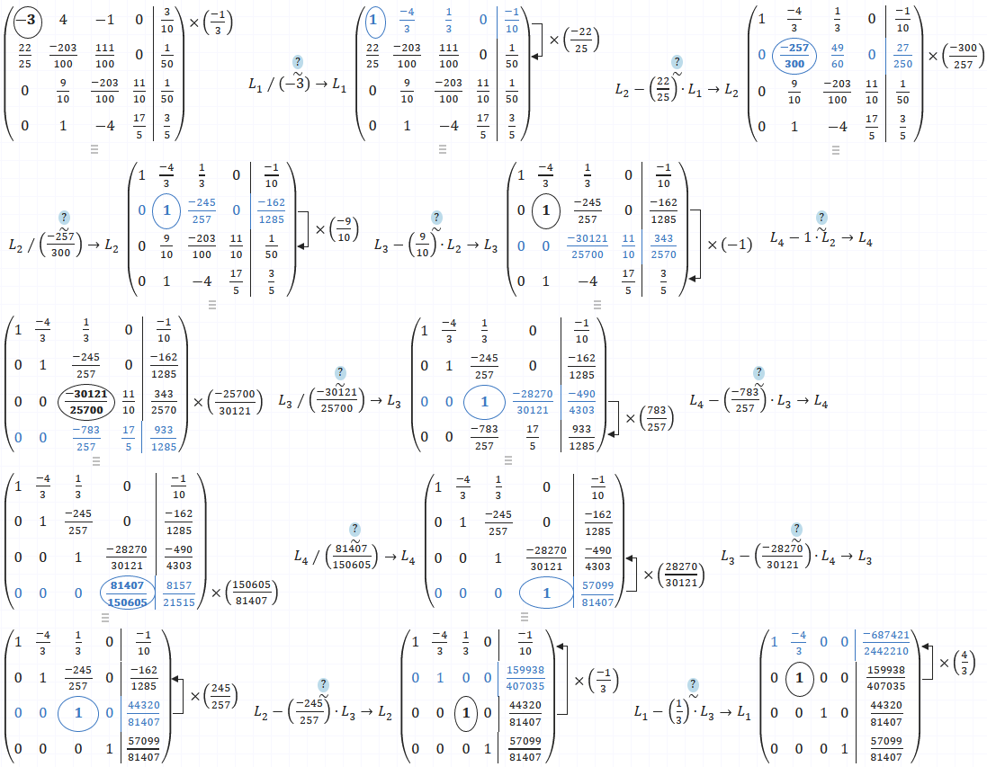

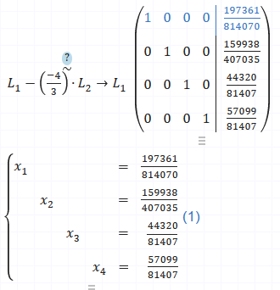
x₀ = 0,8 , y₀ = 197361/814070 = 0,24243738253467146559878143157222 ,
x₁ = 0,9 , y₁ = 159938/407035 = 0,39293426855184443598216369599666 ,
x₂ = 1 , y₂ = 44320/81407 = 0,54442492660336334713231048926996 ,
x₃ = 1,1 , y₃ = 57099/81407 = 0,70140159937106145663149360620094 ,

n = 8 ,
=>
-3y₀ + 4y₁ – y₂ = 3h , i = 0 ,
f₁ (x_{i}, h) y_{i - 1} – f₂ (h) y_{i} + f₃ (x_{i}, h) y_{i + 1} = f₄ (h) , i = 1 .. (n - 2) ,
y_{i – 2} – 4y_{i - 1} + (4h + 3) y_{i} = 6h , i = n - 1 ,.

-3y₀ + 4y₁ – y₂ = 3h , i = 0 ,
f₁ (x₁, h) y₀ – f₂ (h) y₁ + f₃ (x₁, h) y₂ = f₄ (h) , i = 1 ,
f₁ (x₂, h) y₁ – f₂ (h) y₂ + f₃ (x₂, h) y₃ = f₄ (h) , i = 2 ,
f₁ (x₃, h) y₂ – f₂ (h) y₃ + f₃ (x₃, h) y₄ = f₄ (h) , i = 3 ,
f₁ (x₄, h) y₃ – f₂ (h) y₄ + f₃ (x₄, h) y₅ = f₄ (h) , i = 4 ,
f₁ (x₅, h) y₄ – f₂ (h) y₅ + f₃ (x₅, h) y₆ = f₄ (h) , i = 5 ,
f₁ (x₆, h) y₅ – f₂ (h) y₆ + f₃ (x₆, h) y₇ = f₄ (h) , i = 6 ,
y₅ – 4y₆ + (4h + 3) y₇ = 6h , i = 7 ,.

